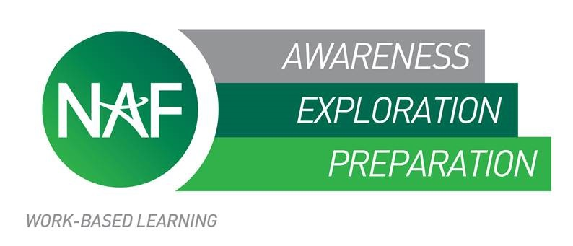
NAF academy students complete an intentional sequence of work-based learning experiences which prepares them to make informed college and career choices and allows them to acquire necessary college- and career- readiness skills.

Participation in work-based learning has a significant positive impact on all involved. Students may benefit most directly, but schools and business partners also gain through getting involved.
STUDENT BENEFITS TO PARTICIPATION IN WORK-BASED LEARNING

- Make direct connections between classroom learning and real world applications
- Build personal ownership of learning by connecting hands-on experiences to individual career goals
- Develop college- and career- ready (‘soft’) skills
- Develop and practice positive work-related habits and attitudes
- Increase motivation to stay in school, earn a high school diploma, and NAF Track Certification
- Develop and work toward achieving college and career goals during high school
- Improve post-graduation employment opportunities
- Secure part-time employment and financial support for post-secondary education
- Establish professional contacts for future employment, mentoring and networking
EMPLOYER BENEFITS TO PARTICIPATION IN WORK-BASED LEARNING
- Develop new projects and ideas with student assistance
- Participate in the curriculum development process
- Develop a pool of skilled and motivated potential future employees
- Reduce training/recruitment costs
- Improve employee motivation and retention
- Support and improve educational programs
- Increase interest in the company and industry by inspiring the future workforce
- Demonstrate corporate social responsibility
- Provide opportunities for employees to use their professional skills to benefit the community
SCHOOL BENEFITS TO PARTICIPATION IN WORK-BASED LEARNING

- Increased high school completion rates
- Increased post-secondary enrollment rates
- Clear connections of core academic and academy courses to college and career applications
- Increased student motivation to stay in school, earn a high school diploma, and NAF Track Certification
- Enhanced ability to meet the needs of diverse student populations through individualized and applied learning opportunities
- Extensive relationships in the community through business partner and advisory board involvement
- Staff development through partner engagement

